Symmetry in nature

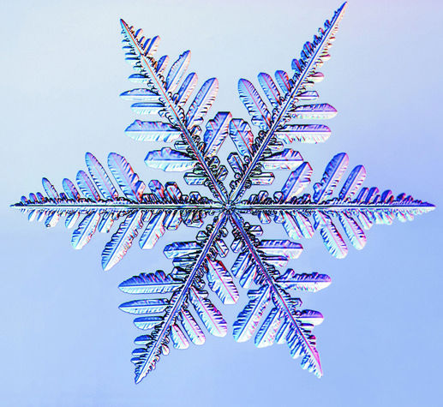
Symmetry, this may be thing which nature relays the most on. Nature is a big fan of symmetry. Take for example a snowflake.
A snow flake is one of the most organized an beautiful things in nature. It looks very complex, but it isn’t. A snowflake can be divided in two equal parts (phase 1), when you take one of these two pieces and copy it. You can turn it 180 degrees and put it next to the original piece. The snowflake is whole again. You can divide the piece of shown in phase 1 in three equal an identical piece (phase 2).

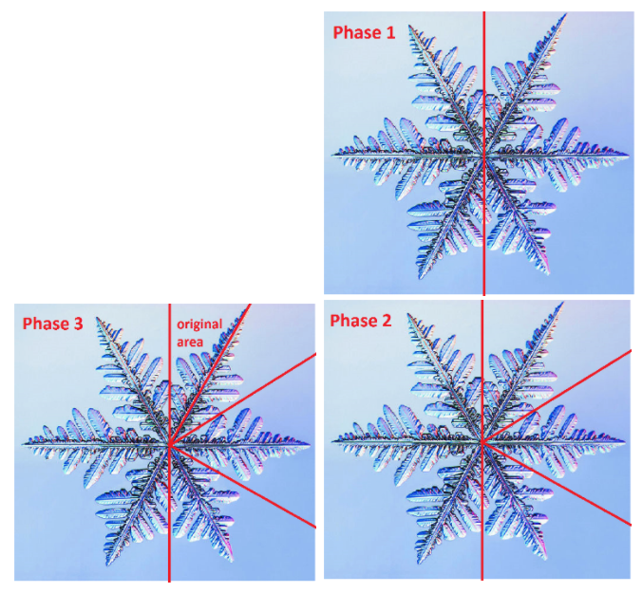
When you copy one of these pieces 6 time more and shuffle them around you’ ll get the original piece again. You can divide this single piece (shown in phase 2) into two identical and symmetric pieces again (phase 3). When you copy this ‘original piece’ twelve times you’ll get the original snowflake.
Nature uses this to avoid having to ‘store’ to much ‘information’ in their DNA. This is one of the biggest reasons why nature loves symmetry.

Symmetry is found everywhere in nature. In Flowers, Butterfly’s, honeycombs, leaves, eyes, wings, feathers, spider webs. In every organism on earth contains a sense symmetry. All organisms use symmetry to not waste space or to make a strong structure.

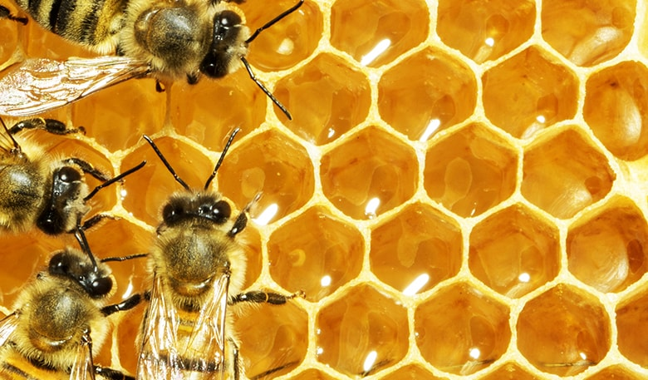
Take for example honeycombs, they have a perfectly symmetric and geometric shape. F or thousands of years, humans have marvelled at the perfect hexagonal figures in honeycombs and wondered how bees can instinctively create a shape humans can only reproduce with a ruler and compass. The honeycomb is a case of wallpaper symmetry, where a repeated pattern covers a plane space also seen in mosaic.
Why do bees make a hexagon shape to store their honey? Well, mathematicians believe that it is the perfect shape to allow bees to store the largest possible amount of honey while using the least amount of wax. Other shapes, like circles for instance, would leave a gap between the cells since they don’t fit together exactly.
Other people, who have less faith in the ingenuity of bees, think the hexagons form by accident. In other words, the bees simply make circular cells and the wax naturally collapses into the form of a hexagon. Either way it is still a ‘invention’ which is fascinating and again very space efficient.
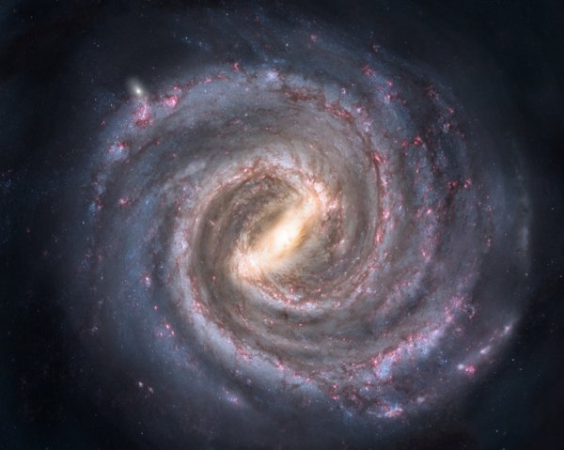
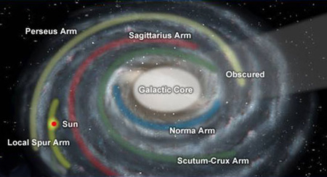
Nature also goes beyond our planet. And symmetry does to. Although this is a very fresh and new subject of thought in the mathematical world, recent researches claim to have discovered a new section on the edges of the Milky Way Galaxy, astronomers now believe that the galaxy is a near-perfect mirror image of itself. Based on this new information, scientists are more confident in their theory that the galaxy has only two major arms, which are basically symmetric
In addition to having mirror symmetry, the Milky Way has another incredible design, like shells and sunflowers, where each “arm” of the galaxy begins in the centre and expands in the same way. As you can see on the picture on the right, the two main ‘arms’ (Perseus Arm and the Sagittarius Arm) move a way from the Galactic Core in the same way. This can also be defined as symmetry, only this research is from what I can getter in a real early stage.

